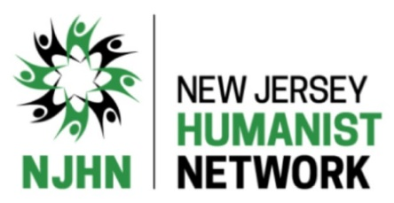
BECOME A SUPPORTING MEMBER OF
NEW JERSEY HUMANIST NETWORK

Please join NJHN and support our organization as we
continue to create a vital Humanist community.

MEMBERSHIP FORM

Type of Membership: New OR Renewal

Membership Level: Individual - $30 Family - $45 Limited Income/College Student - $20
Name
(First) (Last)

Other members ______

Preferred Pronouns_____________________________/_______________________________________

Street Address

City State Zip County

Phone Other Phone ______

E-mail(s)

NJHN is a Chapter of the American Humanist Association (americanhumanist.org) and we provide our membership list to the AHA annually. You can opt-out of having your contact information provided to the AHA. Please check one of the boxes below.

OK to share my information with AHA Do not share my information with AHA

Members will receive all announcements via email. Visit our Membership page for full details.
Signature Date

You can mail this form to: New Jersey Humanist Network, P.O. Box 5521, Somerset, NJ 08875-5521. Make checks payable to: New Jersey Humanist Network. For more info, visit our website at njhn.org, email us at njhn.org@gmail.com, or call us at 732-649-8984.

New Jersey Humanist Network is organized and operated not for pecuniary profit but exclusively for educational purposes within the meaning of section 501(c)(3) of the Internal Revenue Code. All donations are tax-deductible to the full extent of the law. Our Tax I.D. No. is 22-3661045.

